**Enhancing Coordinated Multi-Robot Exploration through Segmentation-Based Navigation**

Team members and contribution:  
  
1) Adam Hardy – 35%



2) Tushar Vishwanath – 27.5%



3) Ishan Patel – 22.5%



4) Vedanth Thakker – 15%



**Abstract**

Our project implements the algorithm first proposed in [1], which involves an efficient and coordinated multi-robot exploration of an unknown environment using segmentation techniques. Robots are assigned to each segment based on the cost of reaching a frontier within that segment. We implement this algorithm in a Python simulation, built from the ground-up by us, and then deployed on procedurally generated environments. The original paper compared its efficiency gain to exploration algorithms which assigned robots purely on the closest frontier with no consideration for the environment structure, but time constraints only allowed us to demonstrate the algorithm’s ability to allow robots to fully explore an unknown environment.

We implemented our own controller, which consists of a simple composite behavior which combines a steering vector towards a provided target as well as a basic repulsive vector away from collisions, with a weight applied to each. Smoothing techniques are applied to the vectors prior to updating the agent’s state, mitigating unrealistic and sharp turns. Combined with a path planning algorithm, robots were typically capable of exploring generated environments with little to no issues. However, there were occasional problems, all related to the path planning approach we used, which we will discuss further later in this report. Otherwise, the actual environment segmentation and assignment algorithm worked without flaws.

The original paper performed experiments in both simulation and on real world hardware. In our case, all experiments we performed were done in our aforementioned hand-crafted simulation. Time constraints again prevented us from utilizing real world hardware.

**Mathematical Model & Theoretical Analysis**

1. Environment:

We begin by describing the simulated environment. We begin by first procedurally generating rooms in a grid-like fashion, given input parameters describing the size of the environment, the minimum and maximum number of rooms, the minimum and maximum size of the rooms, the width of hallways, and whether or not additional hallways should be randomly connected to each room. The algorithm will attempt to best generate the selected number of rooms, but will ignore overlapping generations, thus it is possible for less rooms to generate than what is specified.

Once the environment is generated, it can be optionally scaled up to higher resolutions before generating a polygon representation of the environment, which will be used for more efficient simulation of robot perception. In our approach, we treated the environment grid as an image and detected its contours, which allowed for very quick retrieval of polygon coordinates. Moreover, the somewhat imprecise nature of this method would have the beneficial side effect of sometimes merging rooms together, resulting in an even more complex environment.

The lines of these polygons were then stored using quadtrees as a form of spatial optimization so agents would need to iterate over every wall at every timestep.

Lastly, the center of a room is randomly selected as the starting point for the specified number of robots.

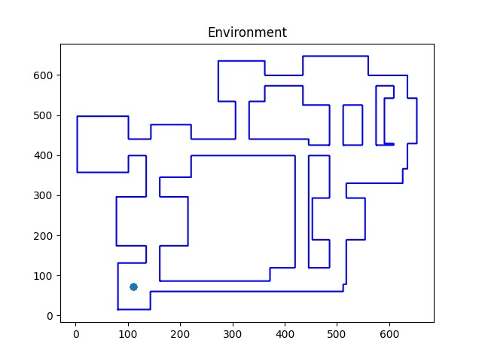

Figure 1 Example Environment Generation. Note the bottom left room being the start point.

1. Robot Perception:

Robots simulate perception with the use of a cone of detection vectors projected from their current position in the direction of their current orientation. If we let $θ_{Oi}$ represent the angle of agent $i$’s orientation vector $O_{i}$, then we can calculate a range of vectors given a desired number of vectors $v$, an angle range $r$, a perception range $p$, and the rotation matrix $R$.

$$θ_{Oi}=atan2(O_{xi},O_{yi})$$

$$θ_{ij}=(θ_{Oi}-\frac{r}{2})+\frac{j}{n-1}×(\left(θ_{Oi}+\frac{r}{2}\right)-(θ_{Oi}-\frac{r}{2}))$$

$$v_{ij}=\frac{R\left(θ_{ij}\right)}{||R\left(θ_{ij}\right)||}*p$$

The agent’s position is then queried in the quadtree to retrieve the most relevant polygon segments and the intersection from each perception vector to each polygon wall is calculated, ignoring intersections that are further away than the perception range. If multiple intersections are found along a single vector, only the closest is considered since a robot would not be capable of detecting through a wall.

1. Robot Controller

The robot controller is easily described as a simple composite behavior combining steering towards a target and an avoidance vector. The steering behavior calculates a vector directly towards a target while the avoidance vector calculates a direct repulsive force given detected intersections within an avoidance radius.

Given a position of a robot $p_{i}$, its current velocity $v_{i}$, and its target $t_{i}$, the steering vector is calculated as

$$s_{i}=t_{i}-p_{i}-v_{i}$$

The avoidance vector $a_{i}$ for robot $i$ is calculated by taking the vector from each potential collision intersection $c_{ij}$ to the robot, normalizing them, and inversely weighing them by their distance $d_{ij}$, ignoring intersections outside of an avoidance range. It should be noted that agents do not have any inter-agent avoidance behavior.

$$n_{ij}=\frac{{c_{ij}-p}_{i}}{|\left|{c_{ij}-p}_{i}\right||}$$

$$w_{ij}=\frac{n_{ij}}{d_{ij}}$$

$$a_{i}=\frac{\sum_{j}{w_{ij}}}{|\left|\sum_{j}{w_{ij}}\right||}$$

The final control acceleration is then calculated using specified scalar weights for the two behaviors. This is added to the previous velocity and further scaled by a turning rate $tr_{v}$, with the final velocity then being clamped to a maximum value, $max_vel$.

$$u_{i}=s_{i}*β+a_{i}*γ$$

$$v_{i}=min⁡(v_{i}*\left(1-tr_{v}\right)+\left(v_{i}+u_{i}\right)*tr_{v}, max_vel)$$

$$p_{i}=p_{i}+v_{i}$$

Lastly, the agent’s perception orientation is updated using the new velocity with a separate turning rate, $tr_{O}$ which can allow room for smoother observation of the environment while turning by decoupling velocity from perception. This is particularly useful if a strong avoidance vector is calculated in the opposite direction of the agent’s original heading.

$$O_{i}=O_{i}*\left(1-tr_{O}\right)+\frac{v_{i}}{\left|\left|v_{i}\right|\right|}*tr_{O}$$

1. Occupancy Grid

An occupancy grid is initialized in the same resolution of the generated environment, with every value starting out as -1, representing unexplored space.

As agents explore, the occupancy grid is sampled along their cone of perception vectors, filling in all space along the length of their perception range or until a wall is detected with 1, representing open spaces. If a wall is detected, the area at the intersection with surrounding padding is filled with 0s.

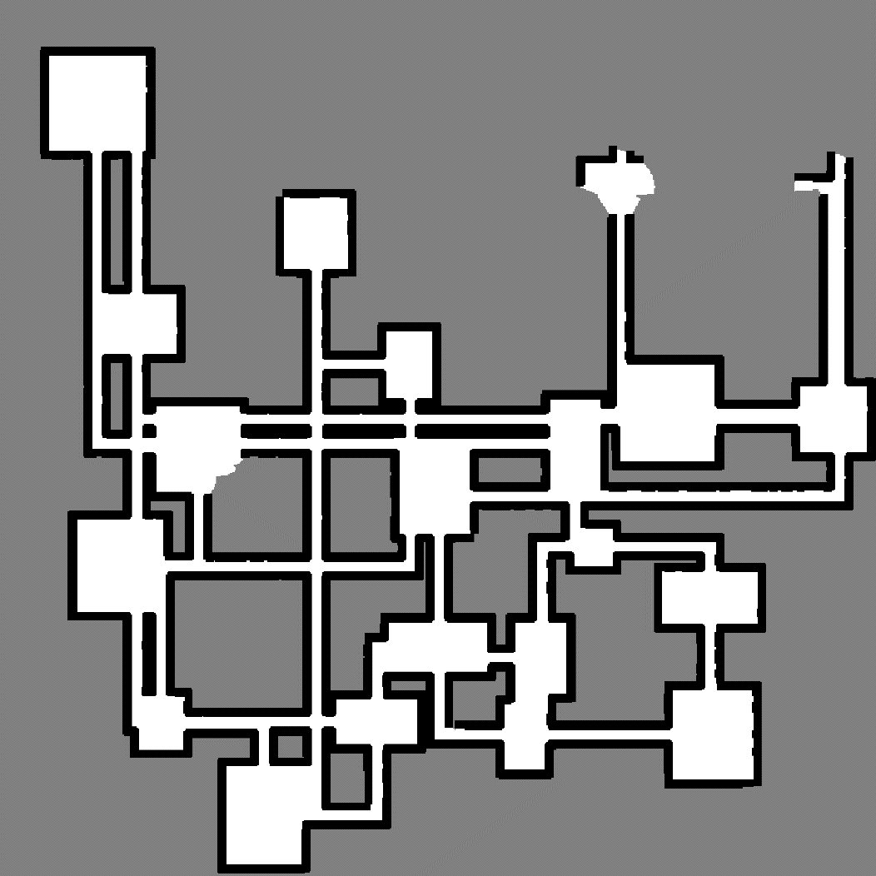

Figure 2 Example Occupancy Grid of Partially Observed Environment

Like in [1], we assume that agents share a single occupancy grid and know their global position in the grid.

1. Voronoi Graph

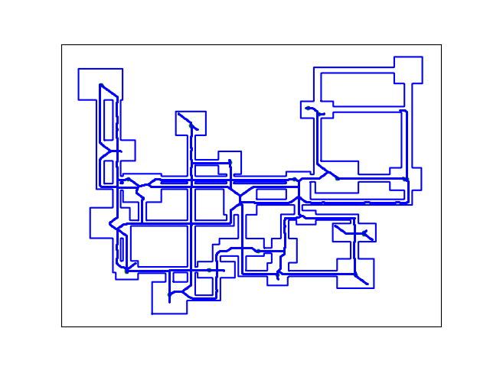In [1], a Voronoi graph is generated using a distance map created from the polygon formed by open spaces. In our approach, we skip the distance map and directly use open spaces in the occupancy grid. Intuitively, the polygon’s “walls” are formed by unexplored spaces and detected walls. This polygon can be skeletonized and turned into a graph.

Figure 3 Example Skeleton of Partially Observed Environment

1. Critical Nodes

We identify critical nodes in a manner similar to [1]. Starting from each leaf node in the graph, we work backwards until we encounter a node with the following properties:

1. It is of degree 2.
2. Any of its neighbors are of degree 3.
3. Segmentation

Once critical nodes are identified, we take the path leading to that node that was identified by traversing to it from the leaf node and add it to a list of possible segments to be assigned to agents.

1. Frontier Cells

[1] does not explicitly go into detail about how it identifies the “frontier” of the environment, instead referring to [2].

[2] discusses a probabilistic approach for identifying frontiers, labeling cells in the occupancy grid as such for any cell that meets its criteria. In our case, we automatically label unexplored cells adjacent to open space as frontier cells.

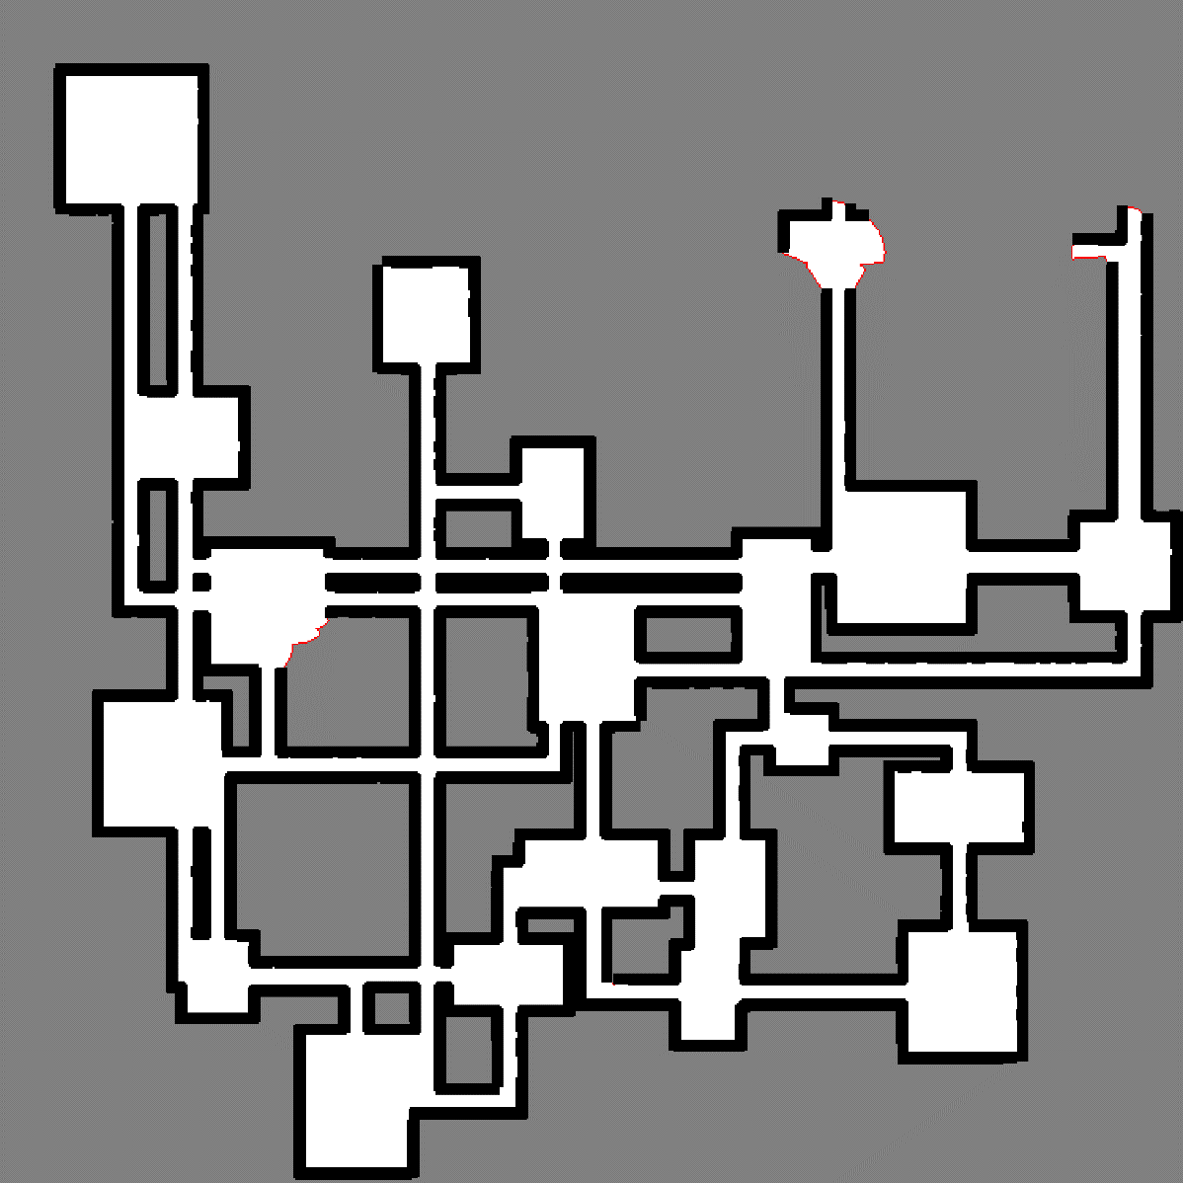

Figure 4 Frontier Overlayed on Occupancy Grid. Note the red cells.

1. Assignment of Agents to Segments & Path Planning

We start by first assigning frontier targets to each segment. In our approach, we simply assign frontier targets to a segment based on the nearest node in the Voronoi Graph. This works in most cases but can on occasion lead to an issue where a frontier cell may be suboptimally assigned to a segment that is in another room, close by Euclidean distance but far by actual distance, which is indeed the problem this algorithm is trying to avoid. However, our approach still leverages the environmental context far more strongly than other methods, as we will explain. This issue could be resolved by utilizing path planning methods to calculate a cost to each frontier cell, but this is computationally expensive. Moreover, even if the assignment of a frontier node to a segment is suboptimal, the cost along the entire Voronoi graph would still be large, thus an agent would typically not be assigned to it at a suboptimal point time, rather simply make unnecessary movements once it is assigned.

Still following the algorithm proposed in [1], we assign segments using the Hungarian method. In our exact approach, we leverage two graphs.

1. The Voronoi graph was created from the skeleton of the polygon formed by open spaces.
2. A more finely grained path graph generated directly from the occupancy grid.

Path planning would be more accurate if we exclusively used the second graph, but it is computationally inefficient, especially if the target is far away from the agent. Instead, we use the finely grained graph to navigate the robot to the Voronoi graph, the Voronoi graph to get the agent as close as it can to its target frontier node, and the finely grained graph again to navigate from the Voronoi graph to the frontier cell. Since robots are still assigned via path costs from a skeleton which represents the shape of the environment, assignments are still typically more optimal than only taking the Euclidean distance into account for every step of the assignment process. The downside is that the initial and final steps of path planning can sometimes be inefficient, or the agent may make redundant movements by needing to follow the skeleton.

Procedure:

1. For each robot:

a. Find the nearest node on the Voronoi graph from the robot's position.

b. For each segment:

i. If the segment has frontier targets:

- Find the closest frontier cell to the robot.

- Find the nearest node in the segment to this cell.

- Calculate a path from the robot to this node via the Voronoi graph.

- Store the path and its cost.

2. Create a cost matrix for all robots and segments.

i. If robot already in segment

- Discount cost.

3. Perform initial assignment of segments to robots using the Hungarian method.

4. Identify any unassigned robots.

5. While there are unassigned robots:

a. Reassign segments to unassigned robots using the Hungarian method.

6. Assign the calculated paths to the robots.

From this point, agents will follow the assigned path, with their target being set to the first point of their path, which is removed as the agent approaches it. Segmentations and paths are recomputed when an agent has completed their path and at least a number of specified timesteps have passed. This parameter specifies a balance between frequent and computationally expensive updates, ensuring assignments and path planning are being done with the most up-to-date information.

1. Summary

Our approach is extremely like the one presented in [1]. Our key differences are that we cut down on path planning computational costs by using the Voronoi graph wherever possible. This presents the aforementioned issues of occasional suboptimal paths or frontier assignments, but still strongly leverages environmental information. [1] states that it uses the occupancy grid for all path planning. We did attempt to implement this as they did, but the computational overhead made simulation infeasible. [1] also does not specify the implementation of their robot controller, so we have no way of knowing they incorporated any additional avoidance routine besides path planning as we did. Based on their simulation output, it does not appear that they decoupled robot perception from movement, as we did.

**Simulation**

Due to time constraints and decreasingly efficient computational performance as environment complexity and/or agent counts increases, it was difficult to get a strong set of samples for a range of experiments. Instead, we opted to first test 5 agents on an increasingly complex environment for 3000 timesteps until they were no longer capable of exploring a significant majority of it. At this point, we began scaling up the number of robots while keeping the environment constant by reusing the same seed for environment generation.

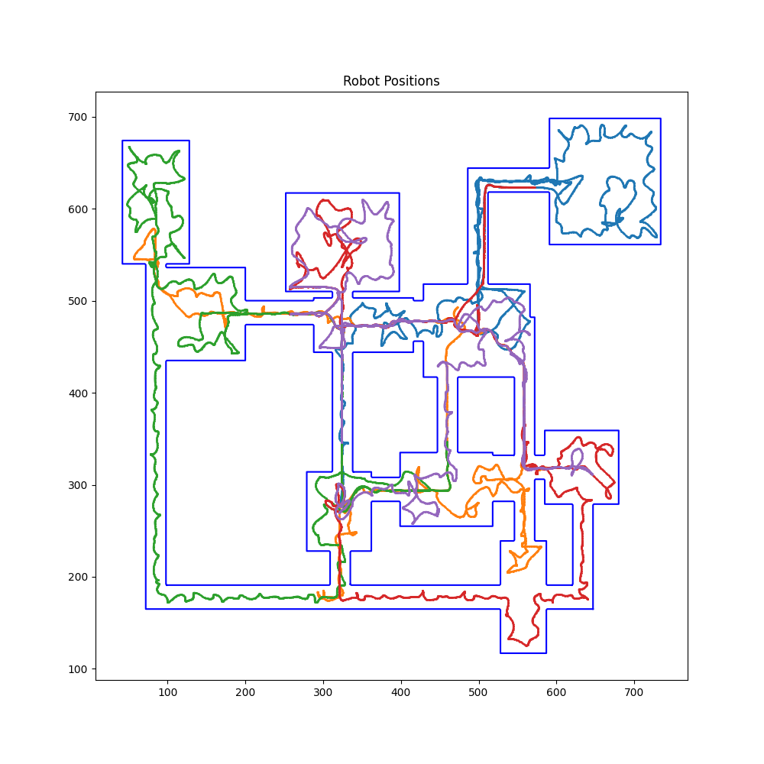

Figure 5 Trajectories of 5 Robots on Relatively Simple Environment Over 3000 Timesteps. Agents easily explore every room and have time to spare.

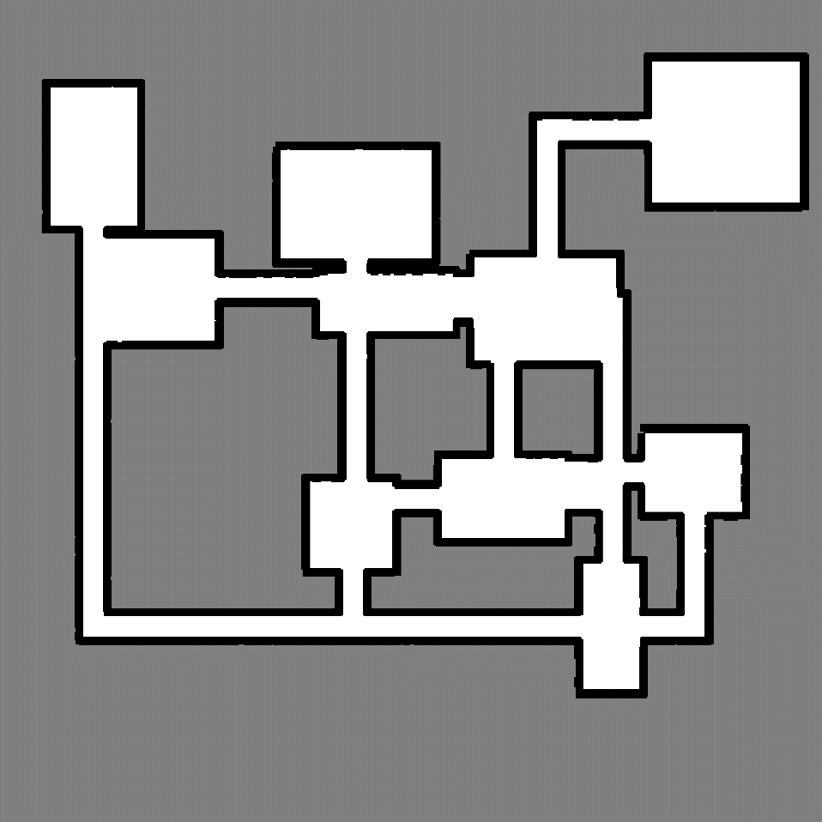

Figure 6 Occupancy Grid of Figure 5



Figure 7 Animated Output of Figure 5

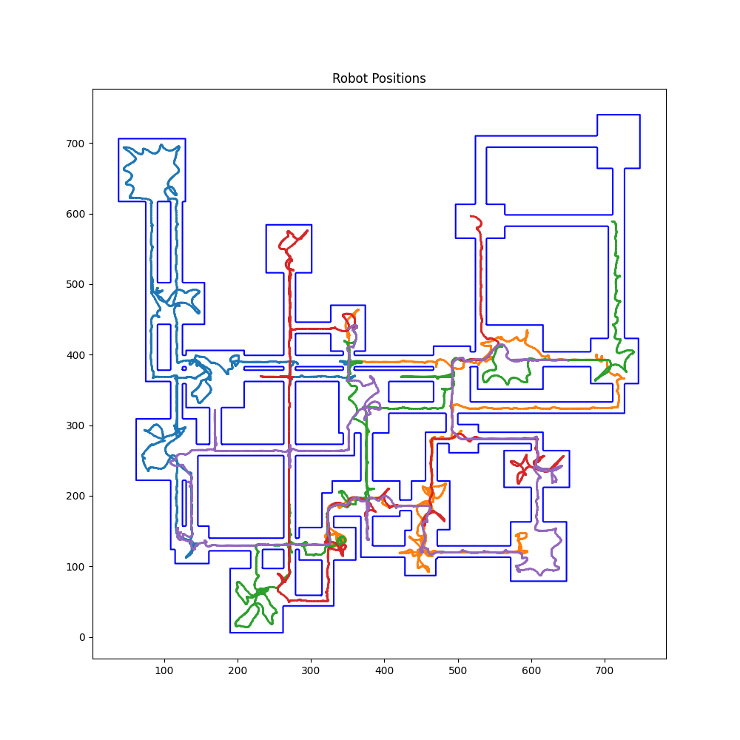

Figure 8 More Complex Environment. 5 Robots. 3000 Timesteps. Agents begin to struggle exploring every room, only missing the top-right corner and a small part of another room.

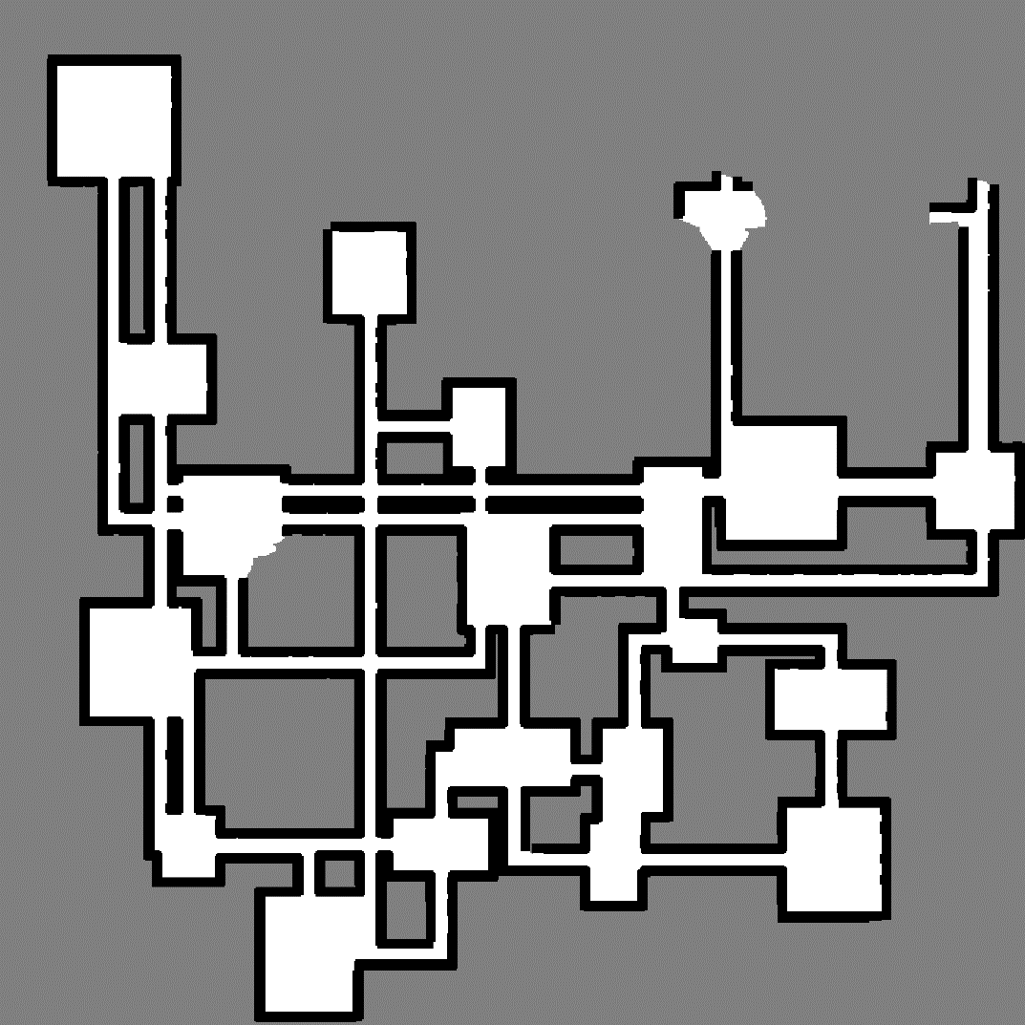

Figure 9 Occupancy Grid of Figure 8



Figure 10 Animated Output of Figure 8

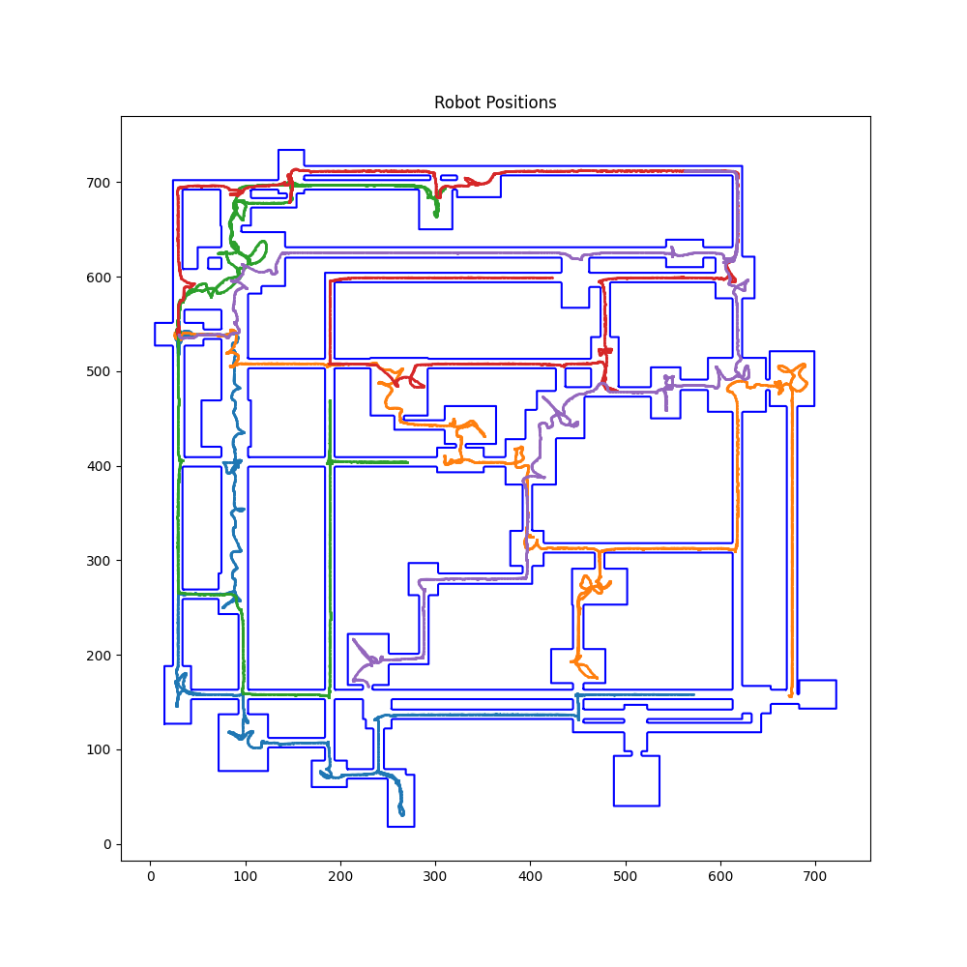

Figure 11 Even More Complex Environment. 5 Robots. 3000 Timesteps. Agents still explore most of the environment but miss a few hallway segments and a few rooms in the bottom right.

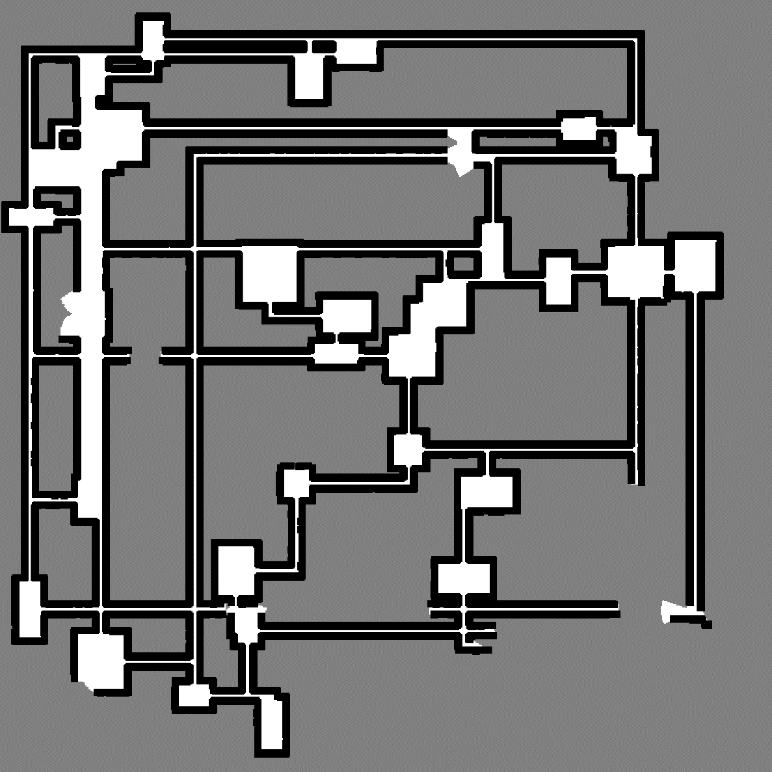

Figure 12 Occupancy Grid of Figure 11.



Figure 13 Animation of Figure 11

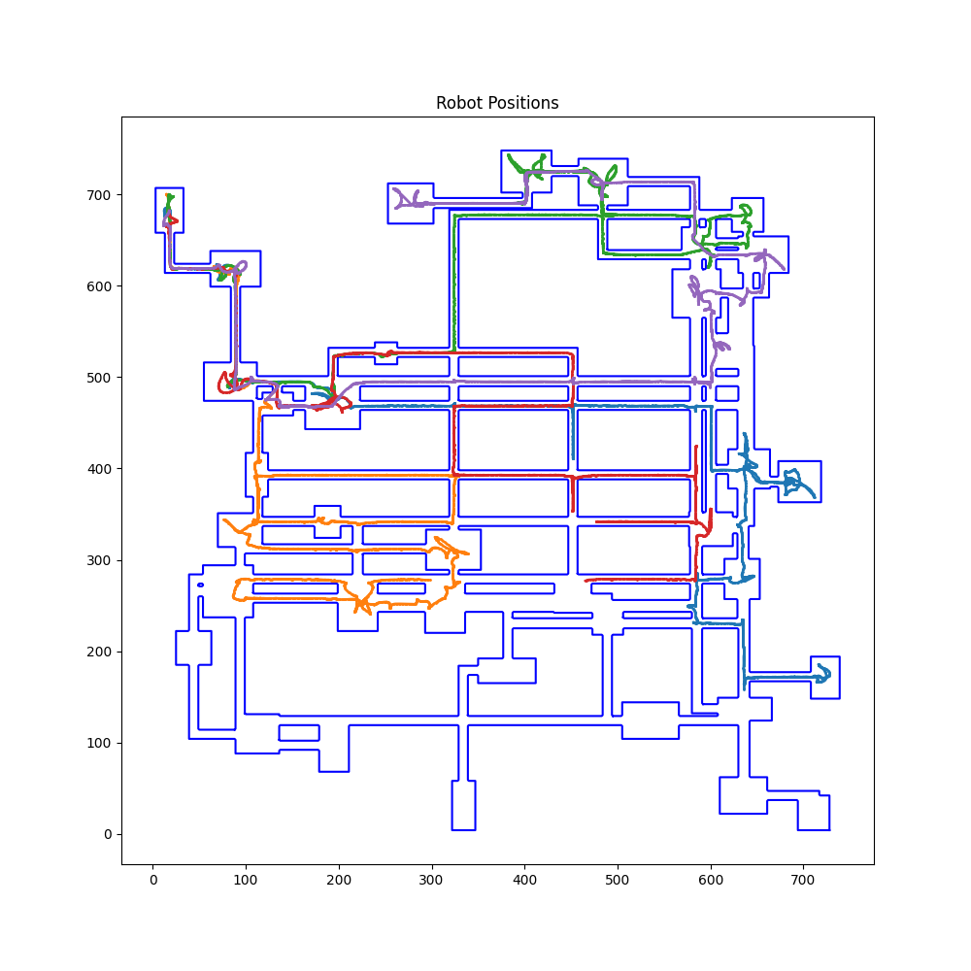

Figure 14 Most Complex Environment. 5 Robots. 3000 Timesteps. At this level of complexity, 5 agents stop being enough to cover almost every room, but still explore over half of the environment.

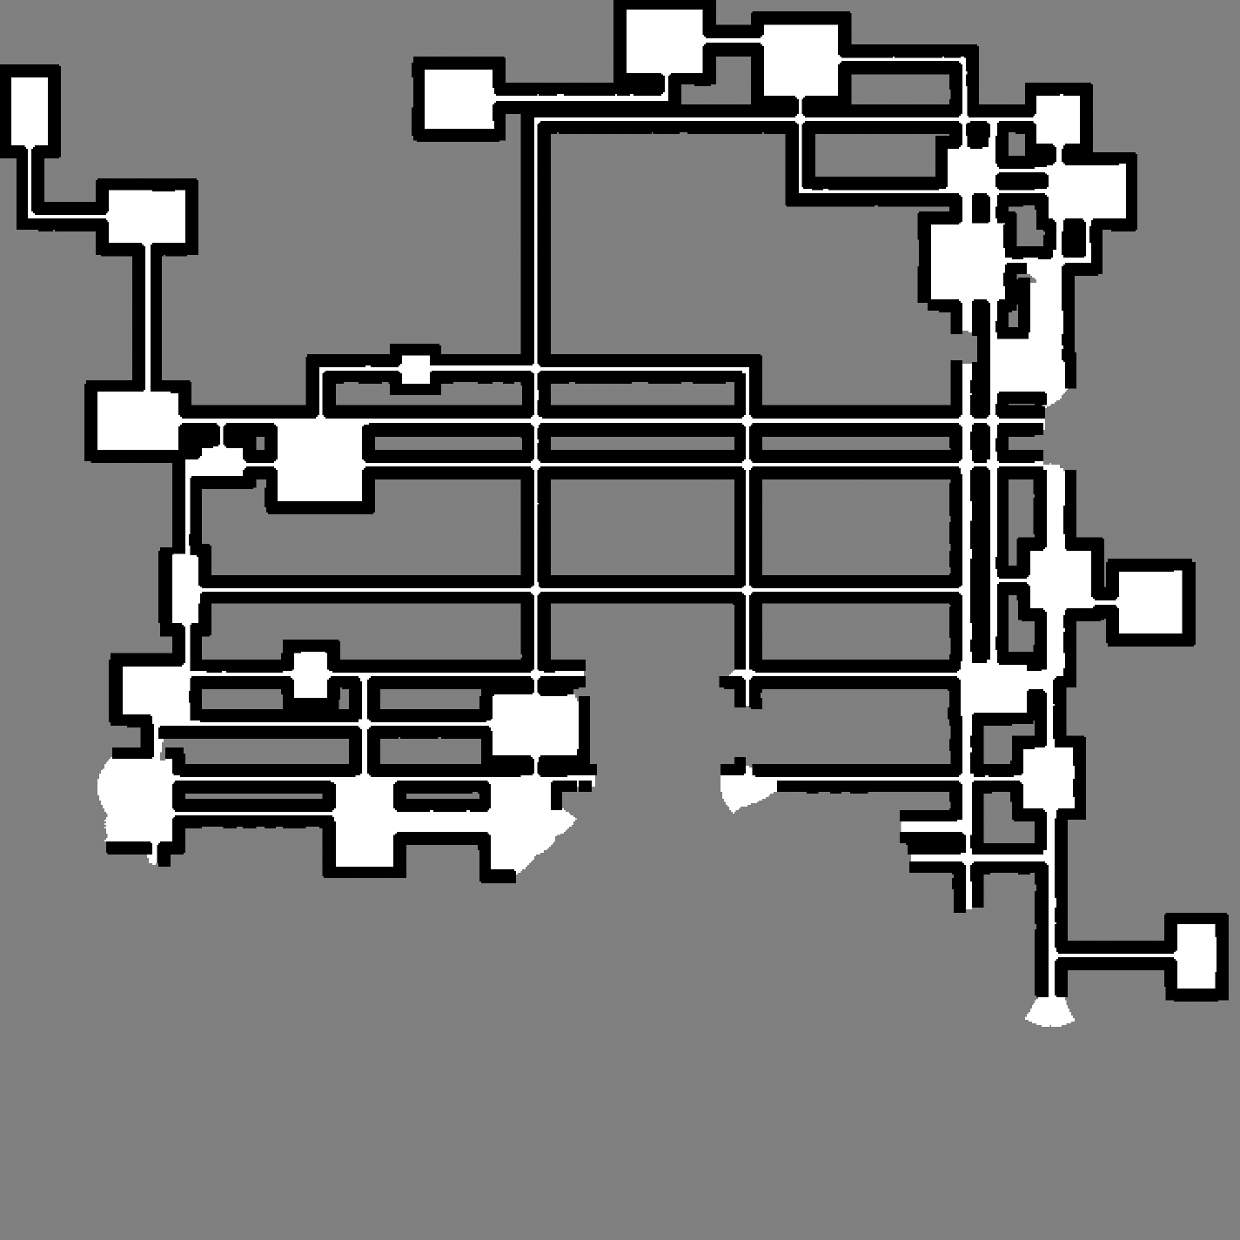

Figure 15 Occupancy Grid of Figure 14

Figure 16 Animation of Figure 14

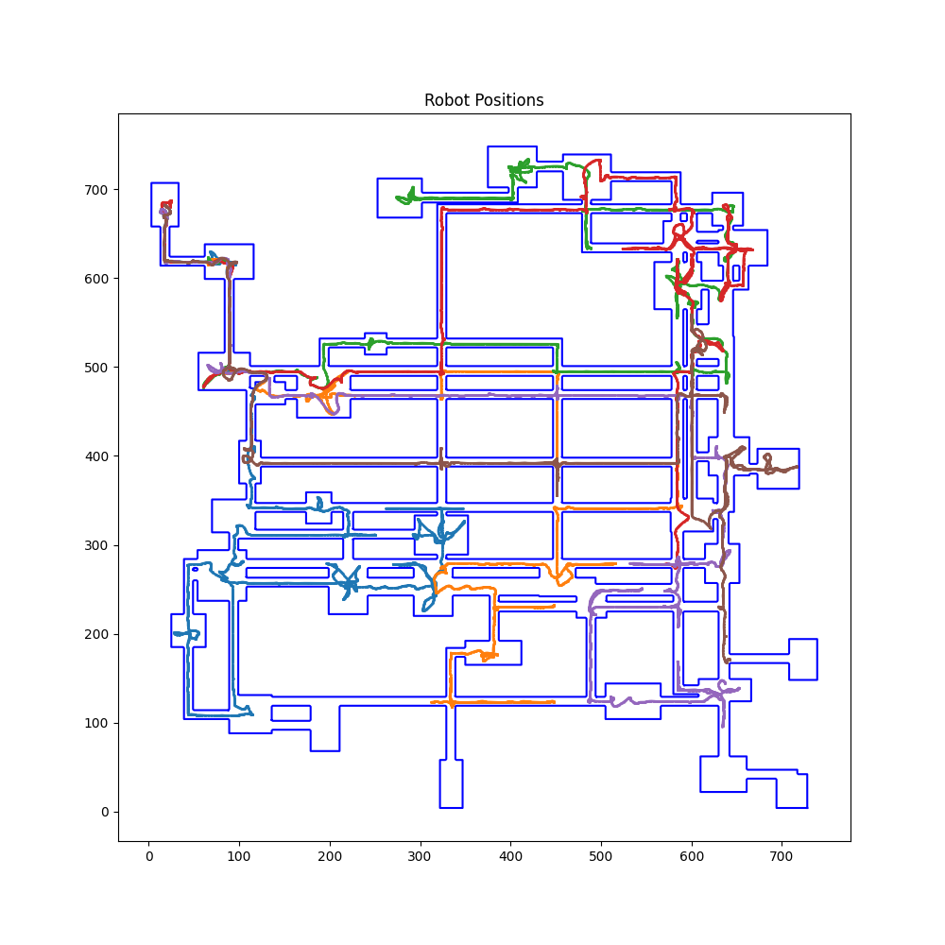

Figure 17 Same Environment. 6 Robots. 3000 Timesteps. The addition of one agent changes the distribution of explored rooms, but overall a notably larger amount of the environment is explored.

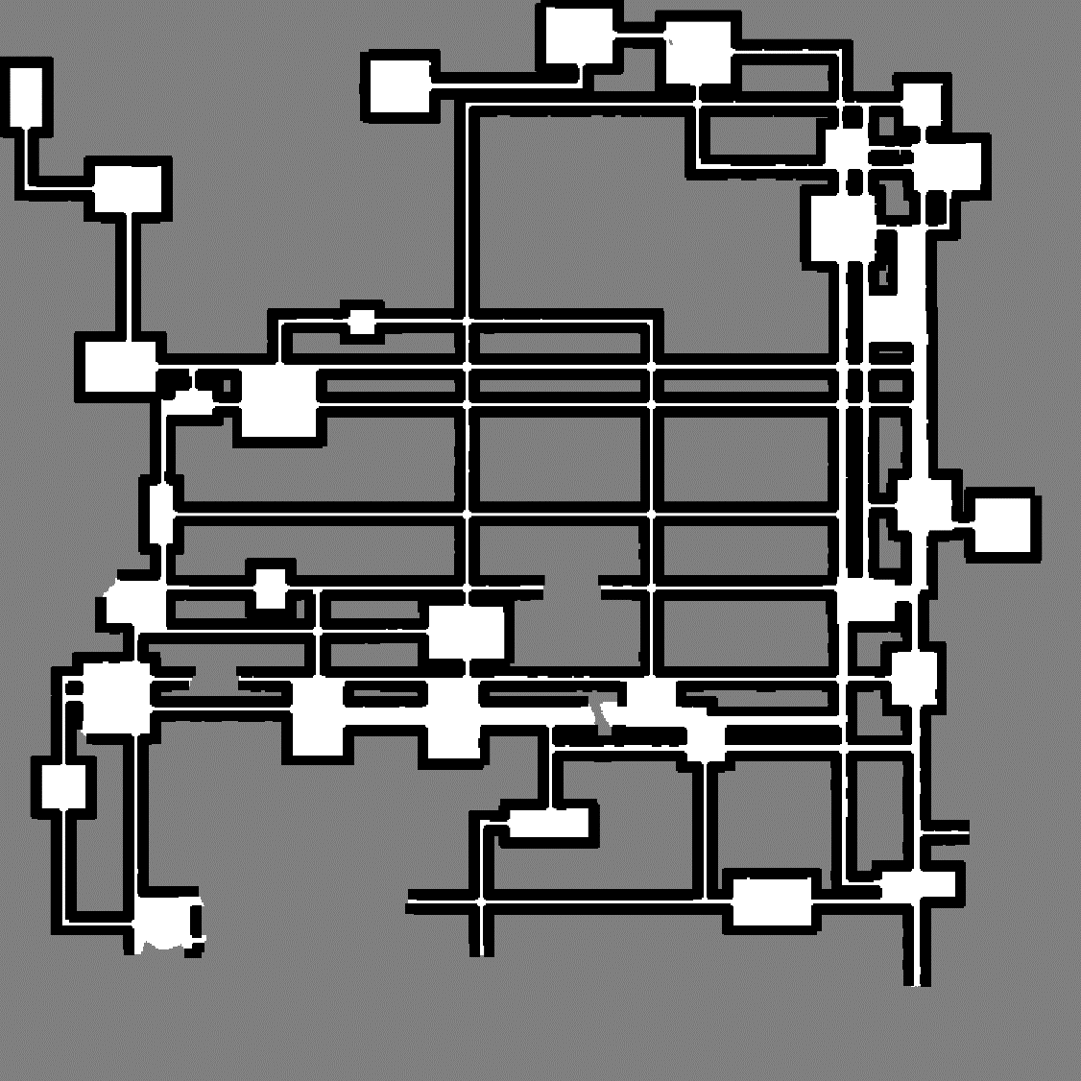

Figure 18 Occupancy Grid of Figure 17



Figure 19 Animation of Figure 17

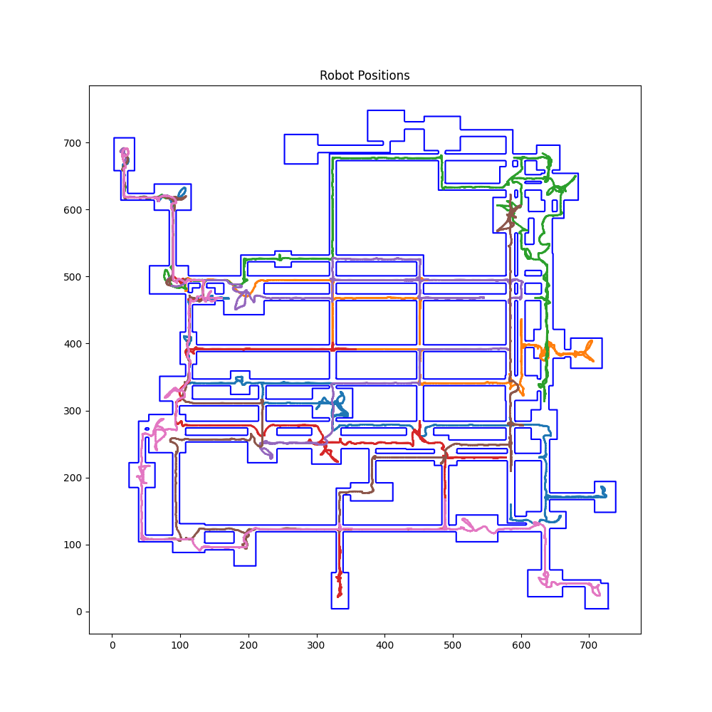

Figure 20 Same Environment. 7 Robots. 3000 Timesteps. Yet another robot results in all but three rooms being explored.

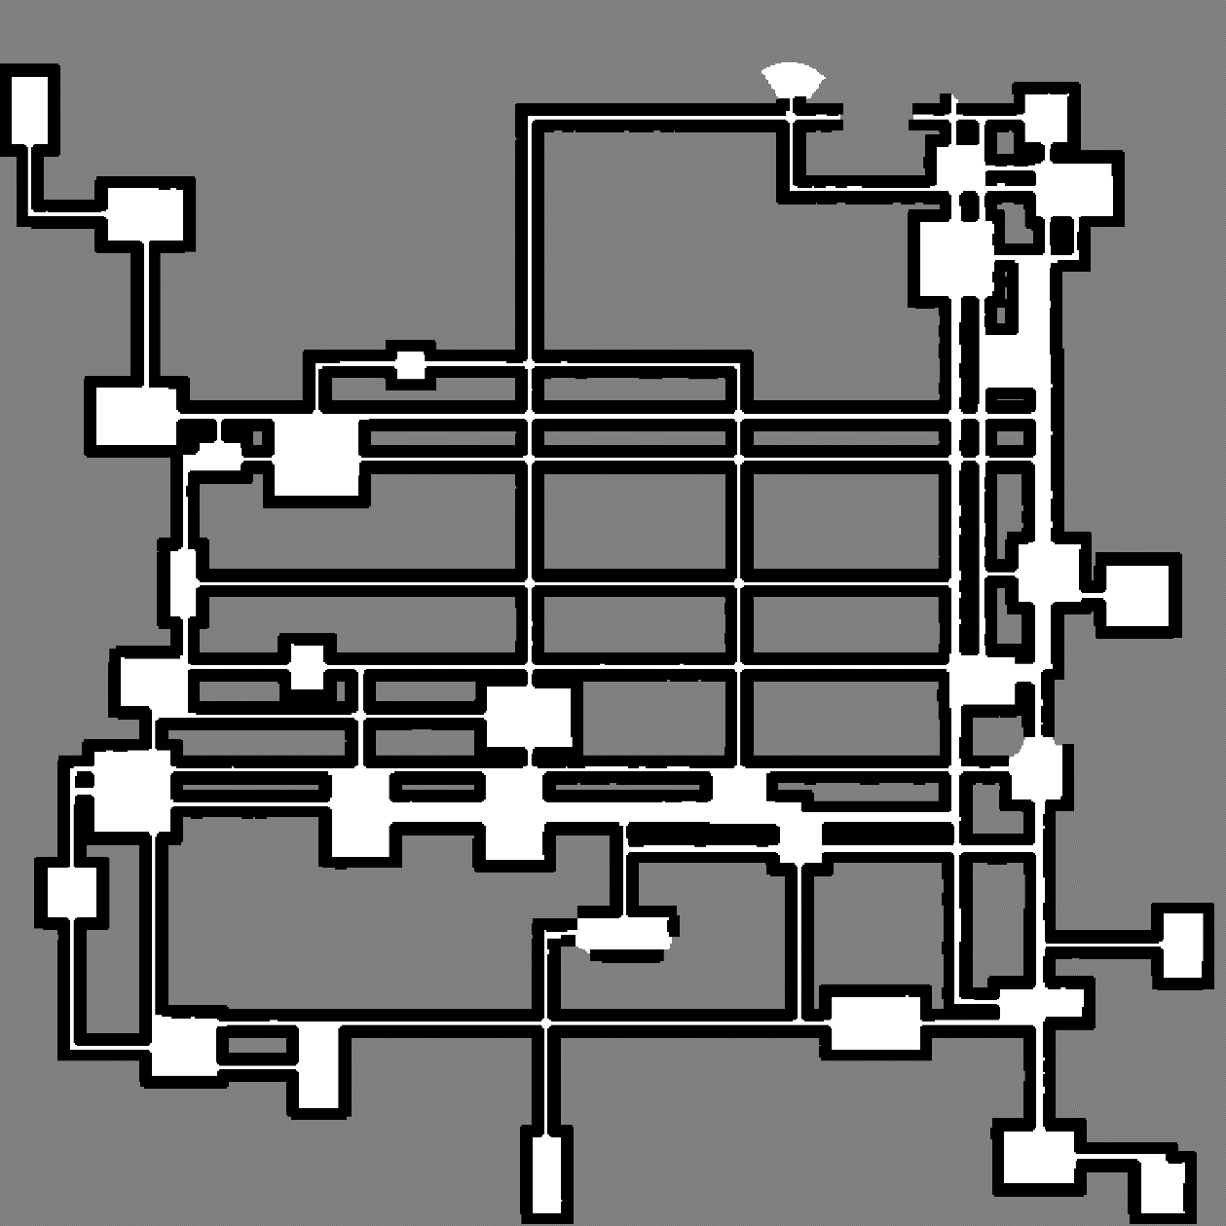

Figure 21 Occupancy Grid of Figure 20

Figure 22 Animation of Figure 20

*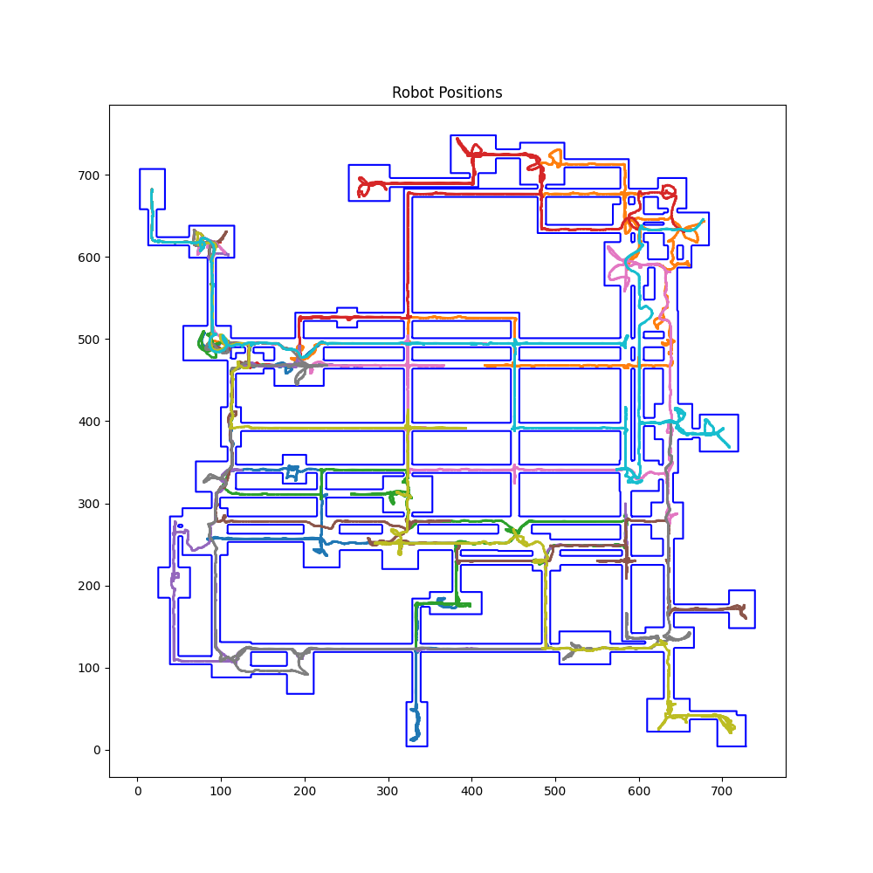Figure 23 Same Environment. 10 Robots. 3000 Timesteps. Exploration complete with time to spare.*

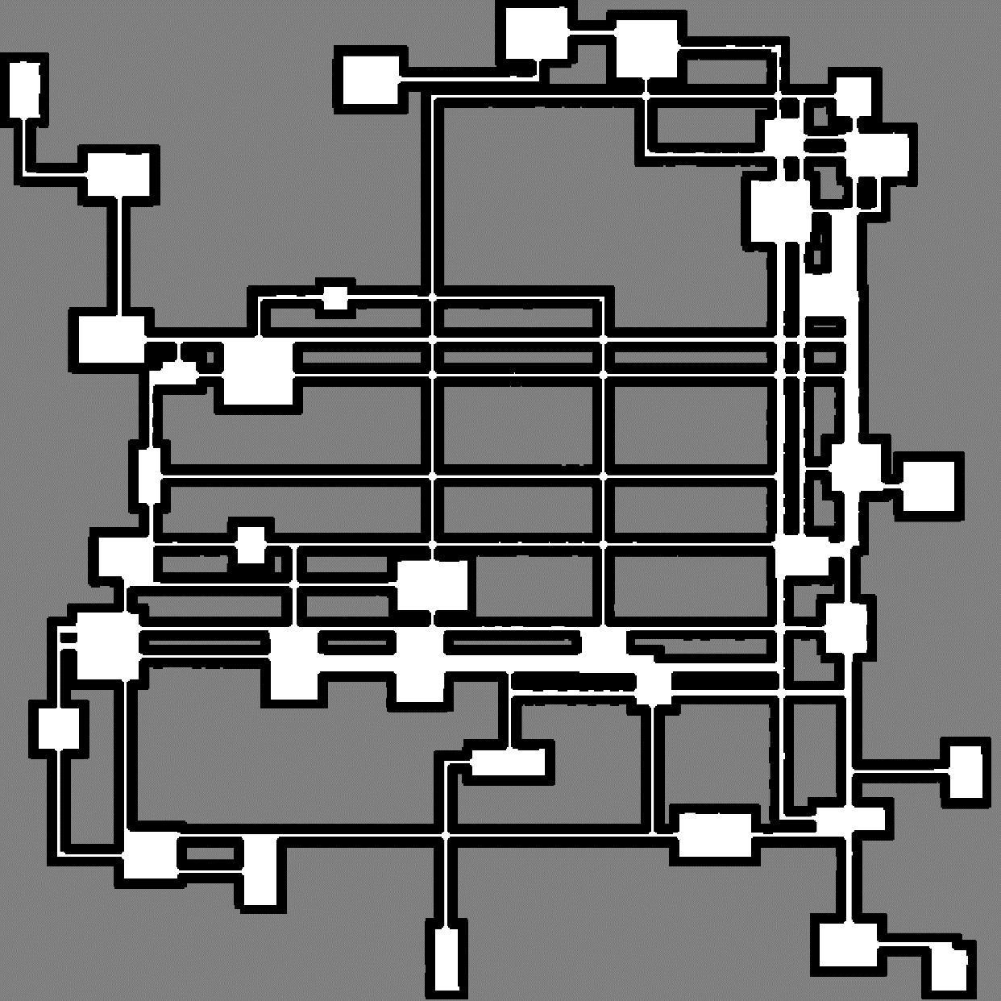

Figure 24 Occupancy Grid of Figure 23



Figure 25 Animation of Figure 23

**References**

[1] “Coordinated multi-robot exploration using a segmentation of the environment | IEEE Conference Publication | IEEE Xplore,” ieeexplore.ieee.org. https://ieeexplore.ieee.org/document/4650734/

[2] B. Yamauchi. Frontier-based exploration using multiple robots. In Proc. of the Second International Conference on Autonomous Agents, pages 47-53, Minneapolis, MN, USA, 1998.

**Appendix**

1. All codes are attached in a zip folder in the submission external to the report file.
2. A brief summary of our changes with respect to simulating [1] has been attached as a separate .txt file in the submission.